Anabela Petrushevikj
D212 PA Task 2
August 14, 2025
Professor Kamara

Part I:
A.
A1. "How can Principal Component Analysis (PCA) be applied to uncover key patterns in hospital patient data?"

A2. The goal for this analysis is to utilize Principal Component Analysis (PCA) to help to reduce the dimensionality of the medical_clean data. The technique uncovers patterns among the data and captures the most significant variables that contribute to explaining the variance. The resulting components are intended to reveal dominant trends among patient characteristics, streamline complex datasets for clearer communication, and provide a foundation for evidence-based, data-driven decisions that enhance both strategic planning and operational effectiveness within the hospital.
Part II:
B.
B1. PCA transforms the original dataset variables into a new set of composite dimensions, with each dimension representing a specific share of the overall variance in the data. This approach reduces the number of variables examined while preserving the patterns that carry the most information. It works by transforming the original, possibly correlated variables such as patient age, income, length of stay, charges, and lab results, into a smaller set of new, uncorrelated variables called principal components. In this dataset, PCA examines the standardized numeric patient variables to identify combinations of features that explain the highest proportion of overall variance. The first component accounts for the greatest share of variability, the second component explains the next largest share while remaining uncorrelated with the first, and the process continues for each subsequent component. The expected outcome is to identify a small number of principal components selected using the scree plot that explain a substantial portion (around 80%) of the total variance. Interpreting these components can uncover meaningful patterns within the dataset, enabling the hospital to condense complex information for clearer reporting, gain deeper insights into patient attributes, and guide strategic decision-making without sacrificing essential details. (Saria, Butte, & Sheikh, 2018)

B2. One key assumption of Principal Component Analysis is that the underlying relationships among variables are linear, meaning that the variation in the data can be effectively captured using linear combinations of the original variables. PCA may be performed even if the variables are not linearly related, but the results may fail to capture the dataset’s most significant patterns. The method is fundamentally based on linear combinations of variables, so non-linear relationships can reduce its effectiveness. (Zhao et al., 2019)
Part III:
C.
C1. These are the selected continuous variables:
- Age
- Income
- VitD_levels
- Initial_days
- TotalCharge
- Additional_charges

C2. To prepare the data for Principal Component Analysis, the six continuous variables identified in C1, Age, Income, VitD_levels, Initial_days, TotalCharge, and Additional_charges, were cleaned and standardized. No missing or duplicate records were detected, so no corrective steps were necessary. Outliers were identified in both the Income and Vitamin D level variables; however, these values were retained because they reflect plausible variations in patient income and vitamin D status. Then, the chosen continuous variables were transformed using the StandardScaler function from the sklearn.preprocessing library to ensure each had a mean of zero and a standard deviation of one. Standardizing the data ensures each variable has an equal influence on the PCA, preventing disparities in units or ranges from skewing the analysis.
A copy of the cleaned and scaled dataset has been attached.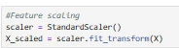
Part IV:
D.
D1. After scaling the data, PCA was applied using scikit-learn's PCA() function to generate a matrix of principal components. This matrix summarizes the data in fewer dimensions while keeping key patterns.
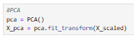
D2. The scree plot applies the elbow rule and ascertains the suitable number of primary components to keep. The scree plot shows that the first four components capture the most meaningful variance.
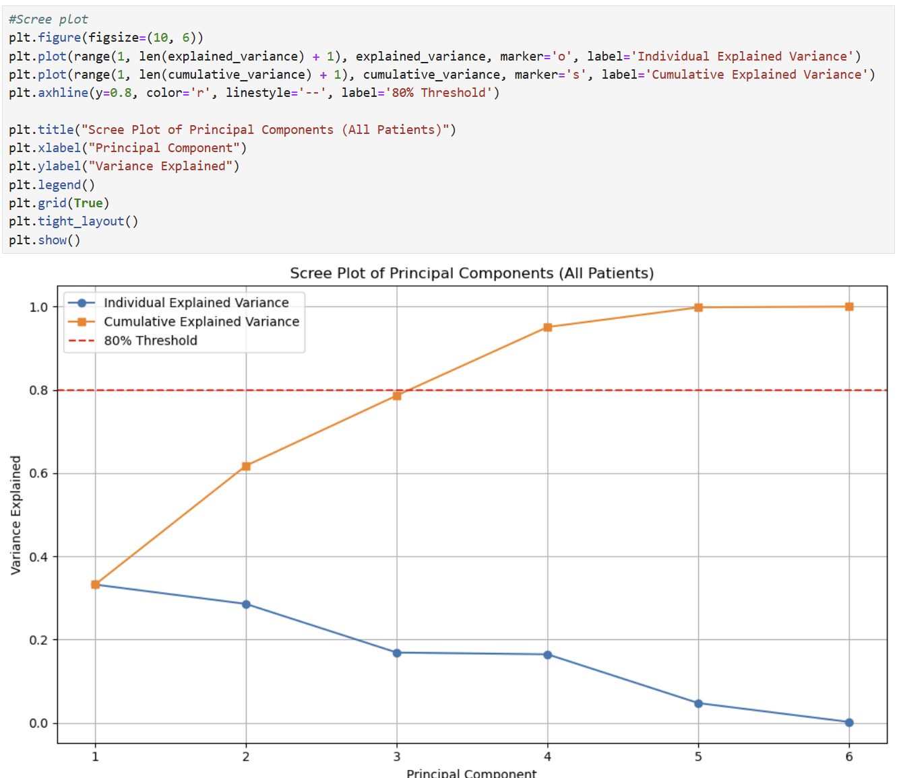
D3. The variance explained by the first four principal components:
- PC1: 33.2%
- PC2: 28.56%
- PC3: 16.87%
- PC4: 16.44%
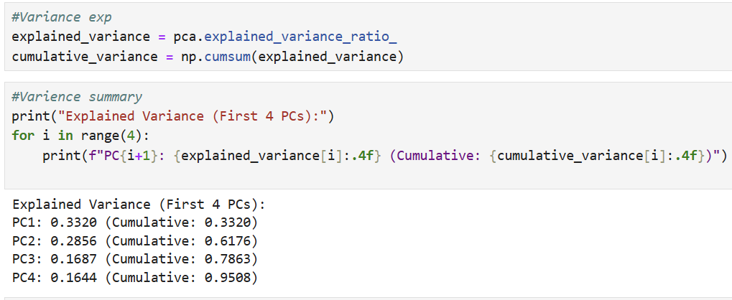
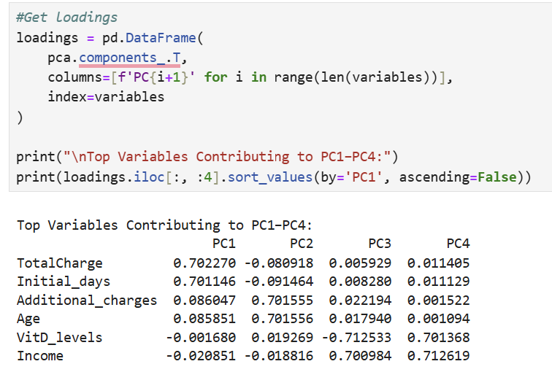
D4. These four components account for 95.08% of the dataset variation.
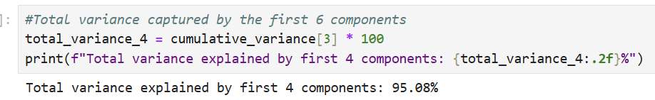
D5. The PCA findings indicated the following variables as the top four in terms of influence; they make up about 95% of the total variability of the data: TotalCharge, Initial_days, Additional_charges, and Age. These features had the highest influence, suggesting they are closely linked to patient variation and possibly readmission risk. TotalCharge and Additional_charges are financial indicators that likely reflect the level of care and treatment intensity, which can be linked to patient complexity or severity of illness. Initial_days measures the length of the initial hospital stay, a known factor associated with patient recovery challenges and potential follow-up care needs. Age is an important demographic variable, as older patients often face higher risks of complications and readmissions. The PCA scatterplot using the first two principal components shows a clear separation between readmitted and non-readmitted patients, suggesting that readmission status aligns with underlying patterns in the data. These results indicate that both cost-related factors and patient demographics are key to identifying high-risk groups. Hospitals could use these findings to focus follow-up care and resource allocation on patients most likely to be readmitted.

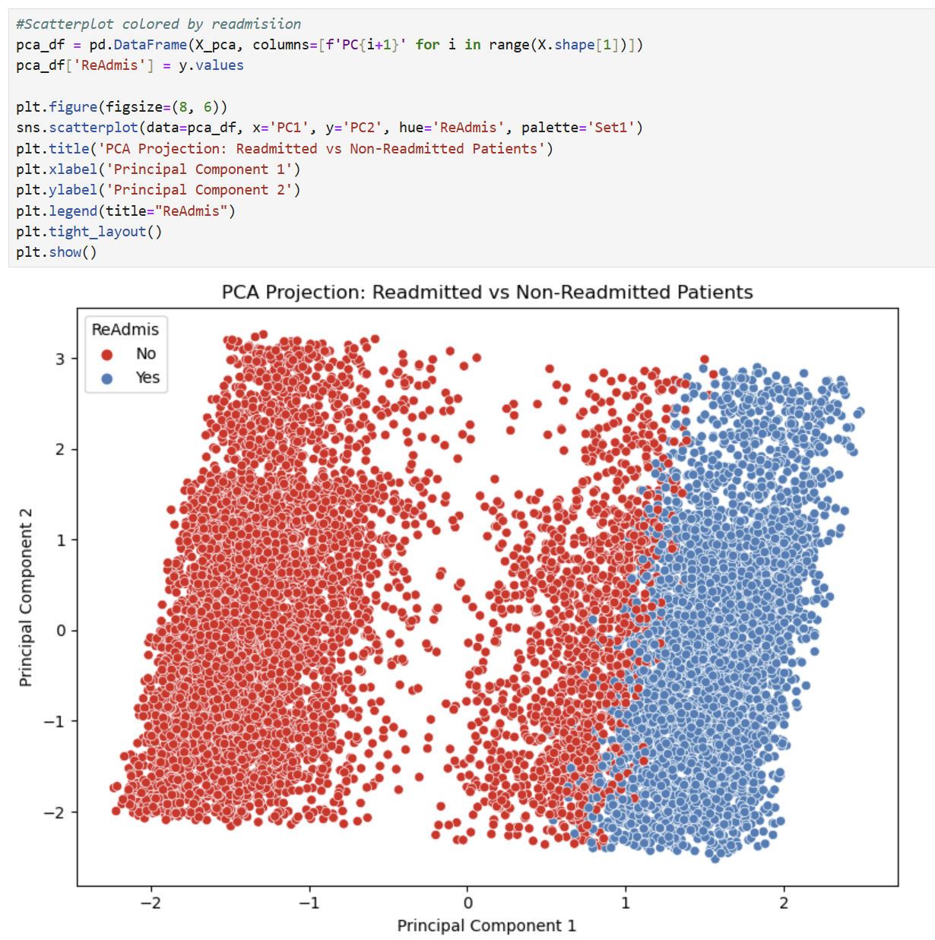
Part V:
E. Code sources:
Wilson, B., Daltyorl, S., Boeye, J., & Hull, I. (2025). Data Mining II. Data Camp. https://app.datacamp.com/learn/custom-tracks/custom-data-mining-ii
F. Sources:
Saria, S., Butte, A., & Sheikh, A. (2018). Better Medicine Through Machine Learning: What’s real, and what’s artificial? PLOS Medicine, 15(12). https://doi.org/10.1371/journal.pmed.1002721
Zhao, Z., Yin, Y., Shang, C., & Xu, Y. (2019). A robust principal component analysis method for identifying condition-relevant gene modules. BMC Bioinformatics, 20, 194. https://doi.org/10.1186/s12859-019-2736-9

